ATLANA POPULATION

Answer 1

ANSWER 2

ANSWER 3

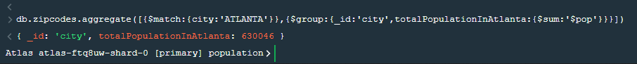

ANSWER 4

POPULATION BY STATE

1.Use aggregate to calculate the total population for each state?

2.sort the results by population ,highrst first?

3.limit the result to just the first 3 results. What are the top 3 states in population?

POPULATION BT CITY

1. use aggregate to calculate the total population for each city (you have to use city/state combination). You can use a combination for the _id of the $group: { city: '$city', state: '$state' }

2. sort the results by population, highest first

3. Limit the results to just the first 3 results. What are the top 3 cities in population?

4. What are the top 3 cities in population in Texas?

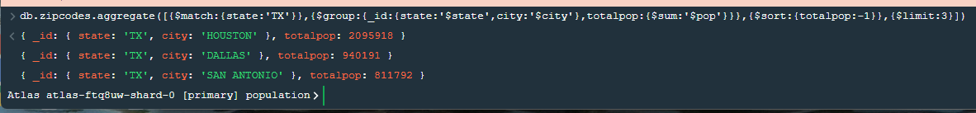

BONUS

1.Write a query to get the average city population for each state.

2. What are the top 3 states in terms of average city population.

